December 14, 2017

**The Human Resource Department**

**Massy Stores Head Office**

**39A Wrightson Road,**

**Port of Spain,**

**Trinidad.**

Dear Sir/Madam,

I am humbly submitting an application for a position within your company.

I have eight (8) years of human resources experience along with a strong passion to professionally enhance and innovate solutions, in order to maximize productivity for your company.

Coupled with my degree in Business Management and Diploma in Marketing, I considered myself to be a dedicated and dependable individual, who have always strive to succeed at my job and contribute positively towards the growth of the organisation I work for. Throughout my career, I was able to develop myself as a conscientious employee and an exceptional team player.

Accordingly, I have attached my Curriculum Vitae and I would be grateful for consideration to be given to me to discuss how I can contribute to your company.

I available to commence employment, immediately.  Please note that I am a holder of a CARICOM Skills Certificate and I am currently residing at Twister's Plaza Apt, Southern Main Rd, Dow Village, South Oropouche, temporarily.

Thank you for your attention, consideration and time.

Yours sincerely,

Hemwatie Madhoo-Chin

**Curriculum Vitae:**

**Hemwatie Madhoo-Chin**

**Address: Twister's Plaza Apt, Southern Main Rd, Dow Village, South Oropouche.**

**Date of Birth: 15th January, 1987**

**Contact info: 793-6095/284-1609 or** [**geetamadhoo2017@gmail.com**](mailto:geetamadhoo2017@gmail.com)****

**Experiences:**

**Guyana Revenue Authority-Human Resource Management Division-Nov 9, 2009 to Nov 3, 2017**

**Human Resource Officer**- Compensation and Benefits- March 01, 2017 to November 3, 2017

**Human Resource Officer and Administrative Officer**- Employment Administration- March 01, 2012 to February 28, 2017

**Senior Clerk**: Recruitment Administration -March 11, 2011 to February 2012

**Clerk III** : Recruitment Administration -November 9, 2009 To March 10, 2011

***Compensation and Benefits Unit***

* Administered the work plan for the Unit.
* Supervised the tasks performed at the National Insurance Scheme, Gratuity Payments, Leave (all types) and Group Insurance Claims-Life, Health and Pension.
* Sensitize and overseen the implementation of the New Leave Software throughout the Authority.
* Prepared and processed all matters as it relates to the administration of the Group Insurance, such as, the Auditing of the Pension Scheme and changing of Insurance Provider, taking notes for Trustee at meetings, Valuation, etc.
* Processed Retirement and Superannuation
* Signed off all documents related to the administering of the above mentioned tasked for all junior level employees.
* Prepared costing, as the need arise and computation of Budget Measures for 2018
* Computation of Termination of Employment and Severance Pay Act (TESPA) benefits.
* Prepared weekly and monthly performance reports.
* Assisted with drafting of various Human Resource Management Policies.

***Recruitment Administration Unit***

* Assisted with the implementation of HR policies to ensure all practices are in compliance with Labour and Employment regulations.
* Trained, supervised and ensured accurate employees’ data are entered into the Human Resource Management Information System (HRMIS) –PeopleNet and Employment Application Software-Correspondence Management Information System (CMIS).
* Developed job postings, assisted in administering the recruitment process-screening and short listing of applications, scheduled and conducted interviews with candidates to determine validity for specific posts.
* Supervised the joining formalities for new recruits and conducted induction.
* Worked closely with payroll and training units- ensured all documentation for staffing actions are sent to payroll section on time and confirmed employees training needs are communicated to the Training unit.
* Prepared correspondences for employment offers, contracts, dismissals, terminations, resignations, disciplinary, acting and responsibility allowances.
* Overseen the maintenance of an efficient application and employee’s overqualified, request for transfer and promotion and manpower planning database.
* Compiled, maintained and ensured the confidentiality of personnel files/records.
* Conducted exit interviews, verified job letters and updated departmental list and general staff list.
* Assisted in providing guidance to Functional Heads on organizational structures, workforce planning and succession planning, etc.
* Tasked with training new recruits and provided continuous training to employees within the unit.
* Performed duties capacity of Administrative Officer to the Head of the Division for one year.

**Colonial Life Insurance Company (CLICO)- Samlall’s Agency- June 1, 2006- March 18, 2009**

**Agency Secretary/Customer Services Representative:**

* Entered New Businesses (Insurance Policies) for Agents into the server using AS400.
* Ensured cash and cheques collected at the Agency are balanced at the end of the day.
* Prepared weekly and monthly activity and production reports for Agency Manager.
* Scheduled appointments and seminars for Manager and Agents.
* Assisted Agents with completion of new business applications such as Life, Annuities, Beneficiaries, declaration source of fund, etc.

Responded to Clients and Agents regarding to policies queries.

* Maintained access to confidential information.
* Received and sort all incoming mails and distributes outgoing mails
* Recorded all policies/contracts and distribute to agents.
* Responsible for stationery and kitchen items requisites and maintenance.

**National Hardware Guyana Ltd- February 12, 2004-May 31, 2006**  
**Inventory Clerk:** *Updated Bin Cards using Cash Receipts and checked stocks periodically and General Stock taking In January.

**Audit Clerk:** Audited Payrolls, vouchers, ensured correct goods are delivered at bonds, verified goods returned, prepared daily charge bills**Education:**

[Sept –Dec 2013] Institute of Distance and Continuing Education-University of Guyana:

**Certificate in Human Resource Management**

[2007-2011] University Of Guyana, Guyana:

**Bachelor’s degree in Business Management and Diploma in Marketing**

[2007] The Business School, Brickdam, Georgetown, Guyana:

**Certificate: Diploma in General Management-American Management Association (AMA)**

[1998-2003] Golden Grove Secondary:

**Caribbean Examination Council (CXC)- Eight (8) subjects**



**Professional Development/Trainings:**

[2016] Customer Services-Consultative Association of Guyanese Industry (CAGI)

[2012] Communication Skills Development Training -Guyana Revenue Authority

[2011] Personnel Practice Policy Seminar- Public Service Ministry

International Labour Organisation  
[2010] Peer Educator’s for HIV/Aids Workplace Education Programme and Peer Counseling Training   
[2012] Male Norms and Gender Violence- Peer Educator Training  
**[2007-2008] Loma -280 and 290 - Insurance Examinations- CLICO**

Guyana Red Cross Society **-**Standard First Aid Training   
Numerous In House Training on Customer Services at CLICO, Guyana.

**Computer Competencies:** Microsoft Excel, PowerPoint, Word, Outlook, very adaptable and understanding any software such as HRMIS and scanning software.

**References:**

**Ms. Janet Abbensetts**- Senior Manager-Human Resource Management, Guyana Revenue Authority, tele: 592-227-8222 ext:4613/4617 and former Senior Manager-**Mr. Maurice Abraham,** tele: 592-609-2312

**Mr. Mohan Samlall**- former Agency Manager- CLICO-Guyana 592-220-6737 / 6725 or **Ms. Shelly Singh**- Supervisor-CLICO-Guyana -592-226-2626

**Mr. Damian Singh**-Supervisor-National Hardware Ltd, tele: 592-227-1961

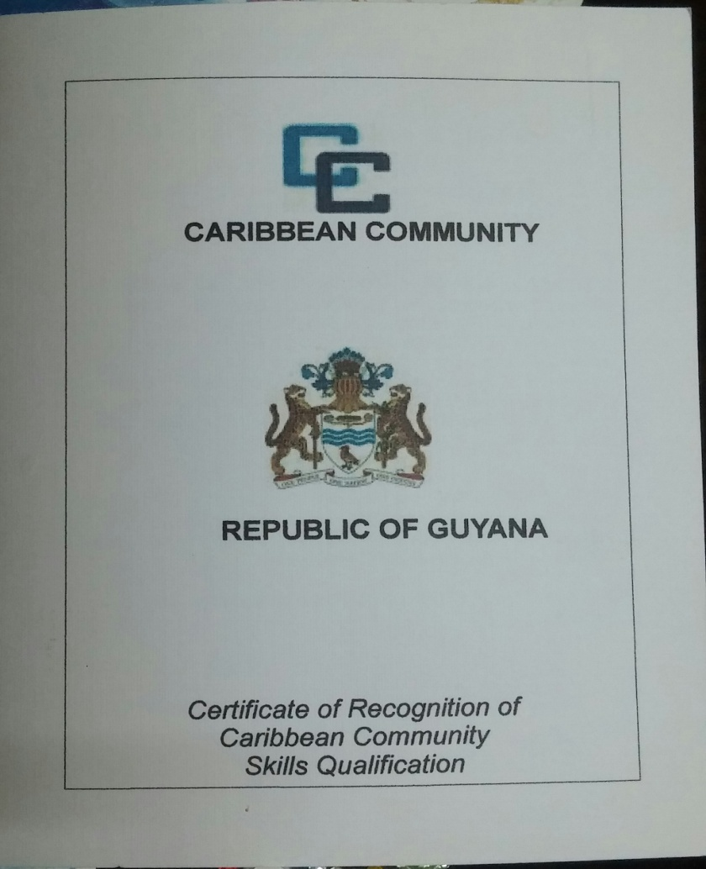

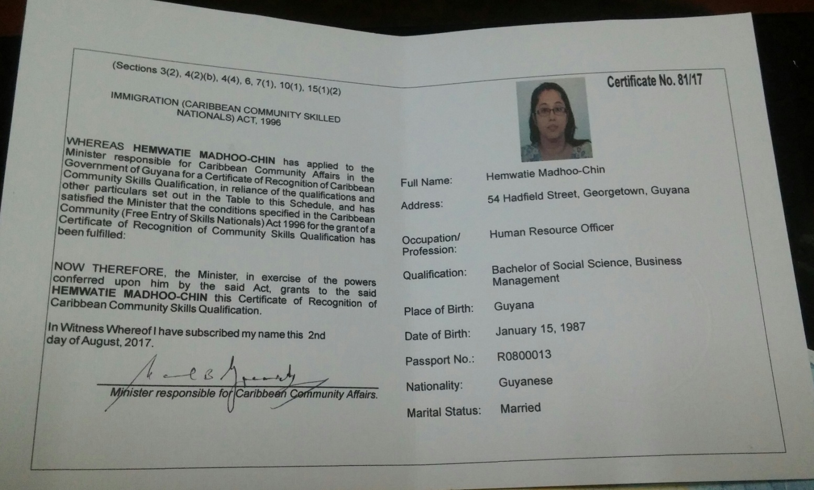

**NB:** I have applied for the Trinidad and Tobago CSME’s certificate. Same is expected to be received in January, 2018.